ESPAÑOL UNO (SPANISH 1): H.M. Jackson High School
2021-2022
Language and communication are at the heart of the human experience.
Everett Public Schools strive to equip students linguistically and culturally to communicate in a pluralistic global society. (Adapted from American Council on the Teaching of Foreign Languages)
Teacher: Megan Friedenson  Online: Canvas  Text: Auténtico 1; Online access through EPS Student Tools or Clever | E-mail: mfriedenson@everettsd.org  Classroom: Portable 4  Help Times: Before & after school times will be posted in our classroom and on Canvas. You can always ask me to set up a time that works for you. I’m here to help you!

LEARNING GOALS:

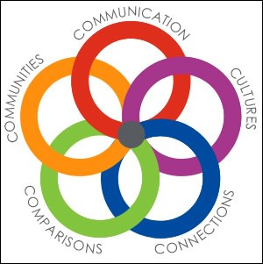 | Themes: getting to know each other, likes/dislikes, activities, describing people, school, food & health, invitations, future plans (“going to), family, home; cultures.  Course Objectives: You will begin to communicate in Spanish, through listening, speaking, reading, and writing, while broadening your awareness of the world and the Hispanic cultures and making connections with other academic disciplines and our local and global communities.  Proficiency Goals: You will see yourself growing throughout the year! You will progress from Novice Low (words), to Novice Mid (phrases), … to Intermediate Low (creative sentences, original questions). More details are on the last pages of the syllabus.  Also: You will learn language acquisition strategies and study skills, get to know new people, and understand how it feels to be a language learner. I hope that you will want to continue learning and using Spanish!

CLASS EXPECTATIONS:
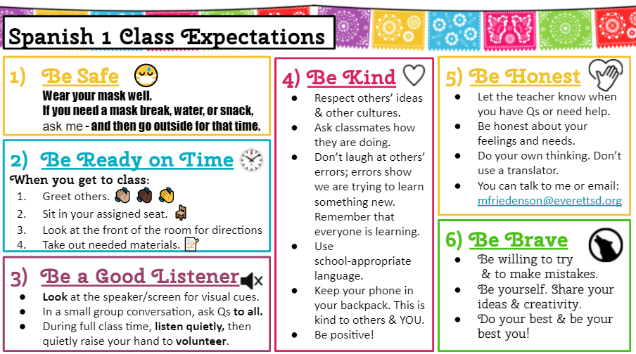
CLASS MATERIALS:
- laptop (keep it charged)
- composition book (100 pages)
- folder just for Spanish class OR a section of a 3-ring binder
- pencil, eraser, pen, highlighter; optional: colorful pens
- textbook to keep at home (optional & recommended; you can access it on-line instead)
- a positive attitude 😊

GRADING:
Grading Categories:  Speaking ~ Interpersonal & Presentational: 20%  Writing ~ Interpersonal & Presentational: 20%  Listening ~ Interpretive: 20%  Reading ~ Interpretive: 20%  Other ~ Vocabulary Practice, Cultural Competency, … 20%  Note: If a student has over 100% in a category, the category grade may be reduced to 100% when calculating end-of-semester grades. This ensures that the grade accurately reflects what the student knows and can do.  Attendance and Absences:  Try to be present every day that you can. (If you are sick, then please stay home.) Learning a language is much easier when you are here to learn and practice with us in person. When you must be absent, you are responsible to make up any learning activities and assessments. Check on Canvas and also check-in with me. Plan to come outside of class time for a short lesson if you missed something new or to make up any assessments. Also practice extra on your own. Do this as soon as you can, because each day we build on what we learned the previous day. | Grading Scale: The 4 point scale will be used for our class.  My goal is for your grade to reflect your abilities to communicate with the Spanish language. This includes your daily language use, as well as your achievement shown through assessments.  As you learn throughout the year, your skills will improve, and sometimes re-takes will be appropriate. Usually the maximum re-take grade is 70%. You are welcome to talk with me about this.
  A | 3.71-4 | (93 -- 100%) | Consistently exceeds standards.
  A- | 3.7 | (90 – 92.9%) | Consistently exceeds standards.
  B+ | 3.3 | (87 – 89.9%) | Meets standards.
  B | 3 | (83 – 86.9%) | Meets standards.
  B- | 2.7 | (80 – 82.9%) | Meets standards.
  C+ | 2.3 | (77 – 79.0%) | Partially meets standards.
  C | 2 | (73 – 76.9%) | Partially meets standards.
  C- | 1.7 | (70 – 72.9%) | Partially meets standards.
  D+ | 1.3 | (67 – 69.9%) | Does not sufficiently meet standards, but does receive credit.
  D | 1 | (60 – 66.9%)
  F | 0 | (59% and below) | No credit.
ACADEMIC HONESTY:
It is so important that you be honest with yourself and your teacher about your learning. Especially when we are using computers, there will be temptations to use Google translate, other tools, or friends/family. As your teacher, I will do my best to make our class interesting and do-able. I will provide you with the resources you need to be successful. As a student, remember: your goal is to learn Spanish! You will learn Spanish by following the teacher’s coaching and by practicing, just like with other skills, and by asking when you need help. You will feel sometimes like you are at a pre-school level learning basic conversation and pronunciation of vowels, and sometimes like you are in elementary school, writing words and then basic sentences. You will make mistakes; that is normal as you are learning. Expect your Spanish 1 communication to feel very basic compared to what you are used to communicating in English; that is okay and part of the process. This is the experience of language learners around the world! And you will make amazing progress!

Language teachers are experienced at detecting the work of translators and other tools/helpers. If I suspect that you have not done your own work, I will ask you to re-do the work or a similar task that I assign. Depending on the task, I will also write a referral to the JHS Administrative Team, with additional consequences. While I encourage you to study and practice with others, I expect you to do your own, original, work to receive credit. We will follow the JHS Academic Honesty policies. The following are examples of plagiarism: using an on-line translator, copying another students’ work, “working together” such that even part of your work is identical or parallel, over-use of dictionaries (3 new words max. for a normal assignment), and excessive help on assignments.

All of your work should be personalized and original. If you feel that the only way you can complete an assignment is dishonestly, do your HONEST best, and then email or talk to the teacher ASAP for help. I care about what YOU are learning and about your integrity as a person.

PRACTICE IDEAS:
- Practice with a friend by talking, texting, or studying.
- Listen to music in Spanish. Add songs in Spanish to your playlist.
- Watch a show / YouTube video / Netflix in Spanish, or with Spanish subtitles.
- Read in Spanish: the textbook, links provided in Canvas, or Google an interesting topic.
- Study flashcards. Ask a family member to do this with you. Study for up to 10 minutes, then take a movement break.
- Do on-line practice activities. Try DuoLingo or another language-learning app.
- Review class examples in your comp book.
- Teach words and conversation phrases to your family.
- Put up sticky notes (or little papers) with words/phrases around your house.

PROFICIENCY LEVELS:

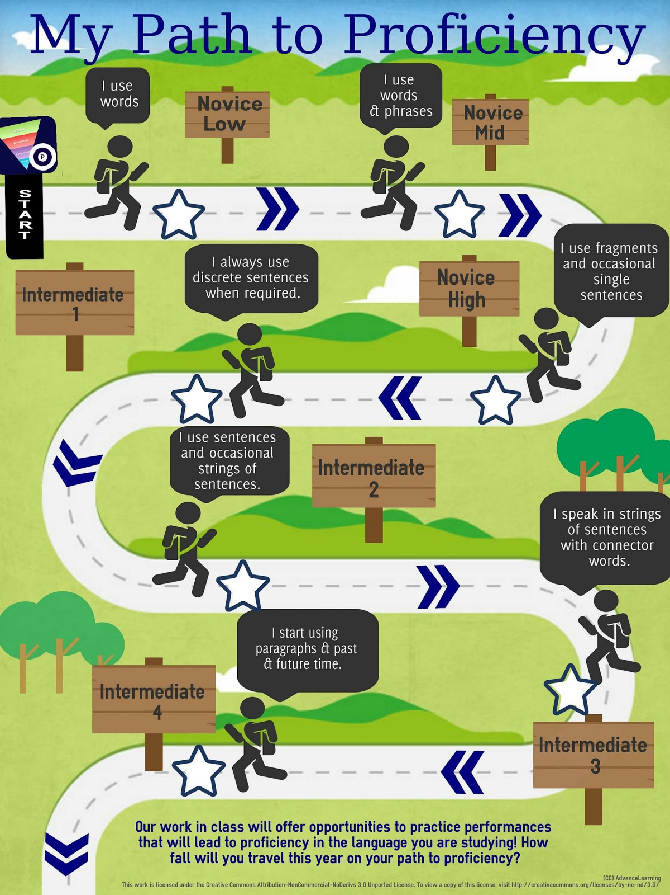

 | INTERPRETIVE | INTERPERSONAL | PRESENTATIONAL
 | Listening/Reading | Person-to-Person  Speaking/Writing | Speaking/Writing
NOVICE  LOW | I can identify memorized or  familiar words when they  are supported by gestures or  visuals in informational texts,  fictional texts, and  conversations. | I can provide information by  answering a few simple  questions on very familiar  topics, express some basic  needs, and express  preferences and feelings  using practiced or  memorized words and  phrases, with the help of  gestures or visuals. | I can introduce myself, express my likes and dislikes, and name very familiar people, places, and objects using practiced or memorized words and phrases, with the help of gestures or visuals.
NOVICE  MID | I can identify some basic  facts from memorized or  familiar words and phrases  when they are supported by  gestures or visuals in  informational texts, fictional  texts, and conversations | I can request and provide  information by asking and  answering a few simple  questions on very familiar  and everyday topics, express  some basic needs, and  express preferences and  feelings using a mixture of  practiced or memorized  words, phrases, and simple  sentences. | I can present information about myself, my interests and my activities, express my likes and dislikes, and present on very familiar and everyday topics using a mixture of practiced or memorized words, phrases and simple sentences.
NOVICE  HIGH    *Goal by  the  end of  Semester 1 | I can identify the topic and  some isolated facts from  simple sentences in  informational texts, fictional  texts, and conversations | I can request and provide  information by asking and  answering practiced and  some original questions on  familiar and everyday topics,  interact with others to meet  my basic needs related to  routine everyday activities,  express, ask about, and  react to opinions using simple  sentences most of the time. | I can present personal information about my life and activities, express my preferences, and present on familiar and everyday topics of interest, using simple sentences most of the time.
INTERMEDIATE  LOW    *Goal by the  end of  Semester 2 | I can identify the topic and  related information from  simple sentences in short  informational texts, fictional  texts, and conversations. | I can request and provide  information in conversations,  interact with others to meet  my basic needs, and express,  ask about, and react with  some details to opinions  on familiar topics by creating  simple sentences and  asking appropriate  follow-up questions. | I can present personal information about my life, activities and events, express my preferences on familiar and everyday topics of interest and explain why I feel that way, and present on familiar and everyday topics using simple sentences.
 | CULTURE, CONNECTIONS, COMPARISONS
In my own and other cultures I can...
- be respectful of others’ perspectives  - describe basic similarities/differences |  | - recognize and use some culturally appropriate behaviors  - connect with people who speak Spanish in our community

